Best Chance Workshop ~ Riverside Church

8660 Daniels Parkway ~ Ft Meyers, FL 33912-0819

Friday: 7:00-9:00 pm ~ AA-The Early Years: Who, When, Where, How

Saturday: 9:00 am-5:00 pm ~ Twelve-Step Workshop, Lunch Included

Saturday Morning: 9:00 am - 9:30 am   Introductions and Seminar Overview  Saturday Morning: 9:30 am - 9:45 am   Break  Saturday Morning: 9:45 am - 10:45 am   Beginners' Meeting - Session 1~~Steps 1, 2 & 3  Saturday Morning: 10:45 am - 11:00 am   Break  Saturday Morning: 11:00 am - 12:30 pm   Beginners' Meeting - Session 2~~Steps 4 & 5  Saturday Afternoon: 12:30 pm - 2:30 pm   Lunch Break (Food Provided by Host Committee)   5th Step with Sponsor or Sharing Partner  Saturday Afternoon: 2:30 pm - 3:30 pm   Beginners' Meeting - Session 3 ~~Steps 6, 7, 8 & 9  Saturday Afternoon: 3:30 pm - 3:45 pm   Break  Saturday Afternoon: 3:45 pm - 5:00 pm   Beginners' Meeting - Session 4~~Steps 10, 11 & 12 | 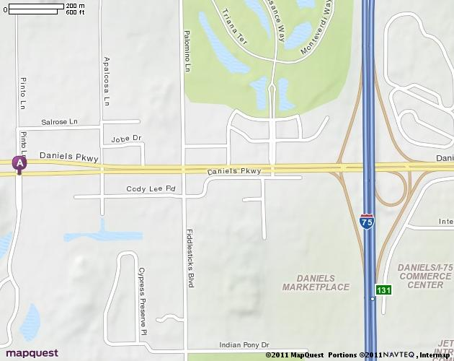

Sunday: 12:00 noon-2:00 pm ~ How to Listen to God

From the North (Tampa / St Petersburg area)  Take I-75 S toward NAPLES.  Take the DANIELS PKWY exit, EXIT 131, toward CR-879/S W FLORIDA INTL AIRPORT/CAPE CORAL.  After 0.3 miles, take the ramp toward CAPE CORAL.  After <0.1 miles, turn RIGHT onto DANIELS PKWY.  After 1.0 miles, make a U-TURN onto DANIELS PKWY.  After < 0.1 miles, 8660 DANIELS PKWY is on the RIGHT. | From the North East (Orlando, FL area)  Take I-4 W  Merge onto CR-557 S via EXIT 48 toward LAKE ALFRED/WINTER HAVEN.  After 6.7 miles, Turn LEFT onto W HAINES BLVD/CR-557  After 0.1 miles, turn RIGHT onto S LAKE SHORE WAY/US-17-92/US-17 S/US-92 W. Continue to follow US-17-92/US-17 S/US-92 W.  After 1.2 miles, turn SLIGHT LEFT onto US-17 S / SR-555 S. Continue to follow US-17 S.  After 87.2 miles, merge onto I-75 S via the ramp on the LEFT toward NAPLES.  After 32.6 miles, take the DANIELS PKWY exit, EXIT 131, toward CR-879 / S W FLORIDA INTL AIRPORT / CAPE CORAL.  After 0.3 miles, take the ramp toward CAPE CORAL.  After <0.1 miles, turn RIGHT onto DANIELS PKWY.  After 1.0 miles, make a U-TURN onto DANIELS PKWY.  After < 0.1 miles, 8660 DANIELS PKWY is on the RIGHT. | From the South or South East (Miami, Ft Lauderdale, Coral Springs area )  Take I-95 South or North to I-75.  Merge onto I-75 N toward ALLIGATOR ALLEY/NAPLES (Portions toll).  After 113.9 miles, take the DANIELS PKWY exit, EXIT 131, toward SW FLORIDA INTERNATIONAL AIRPORT/CAPE CORAL.  After 0.3 miles, Turn SLIGHT LEFT to take the ramp toward USF/ECC/CAPE CORAL  After 0.1 miles, merge onto DANIELS PKWY.  After 1.2 miles, make a U-TURN onto DANIELS PKWY.  After < 0.1 miles, 8660 DANIELS PKWY is on the RIGHT.

